1. Creating and Renaming Files/Directories
Create a directory named test_dir using mkdir.
Inside test_dir, create an empty file called example.txt.
Rename example.txt to renamed_example.txt using mv

ANS : mkdir , cd , touch , mv
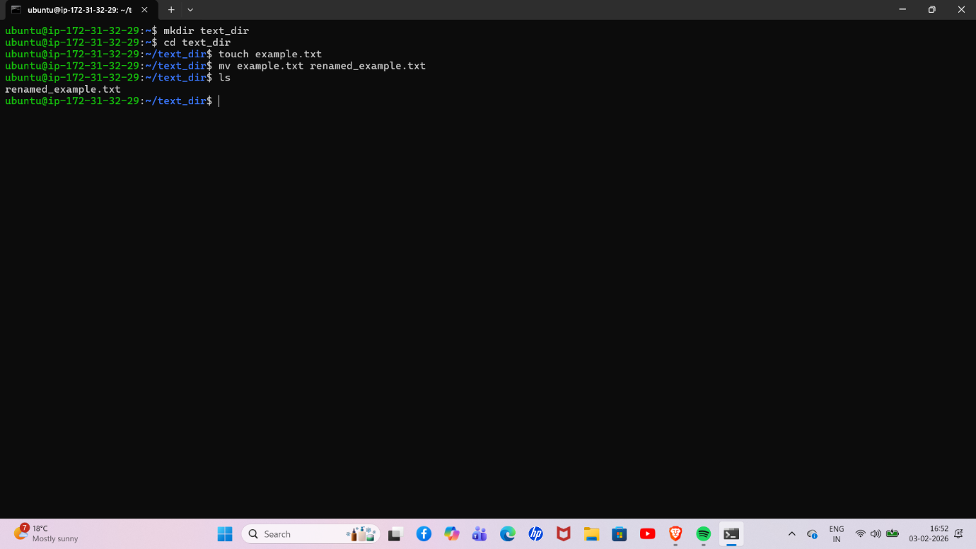

2. Viewing File Contents
Use cat to display the contents of /etc/passwd.
Display only the first 5 lines of /etc/passwd using head.
Display only the last 5 lines of /etc/passwd using tail.

Ans cat /etc/passwd , head -n 5 /etc/passwd , tail -n 5 /etc/passwd

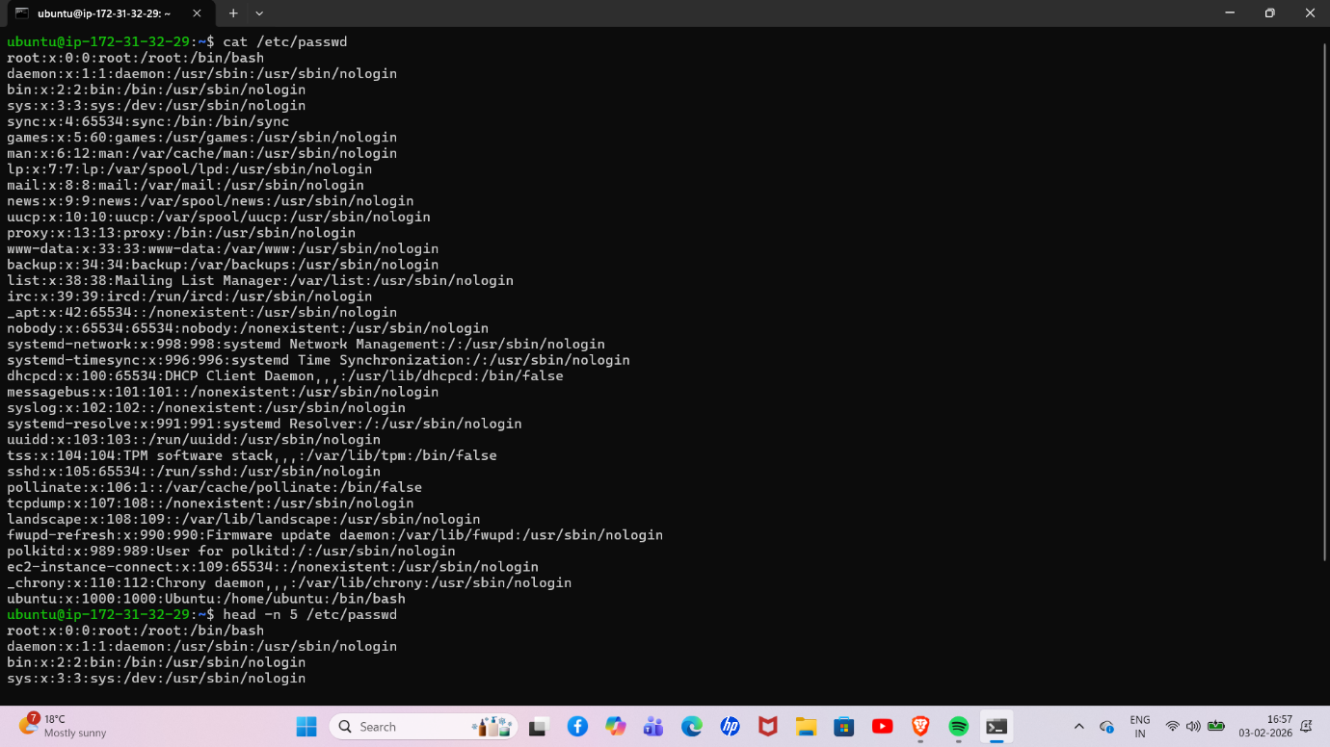

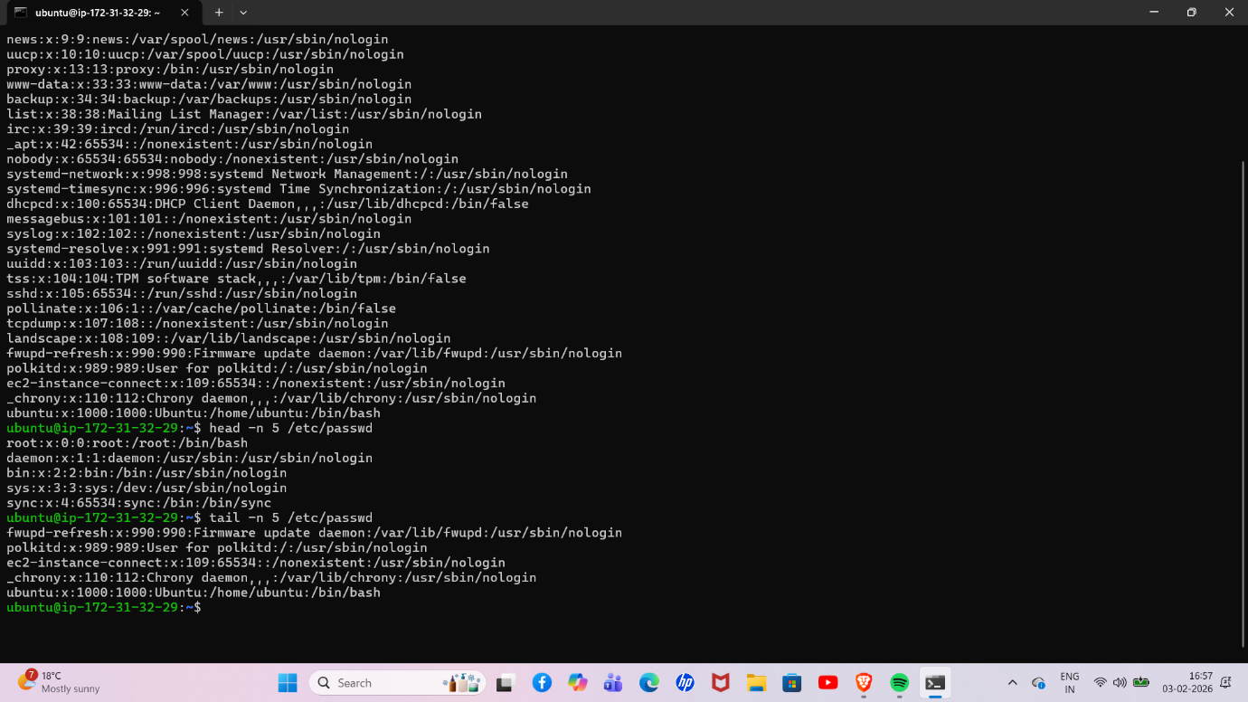

3.Searching for Patterns
Use grep to find all lines containing the word "root" in /etc/passwd.

Ans : grep root /etc/passwd

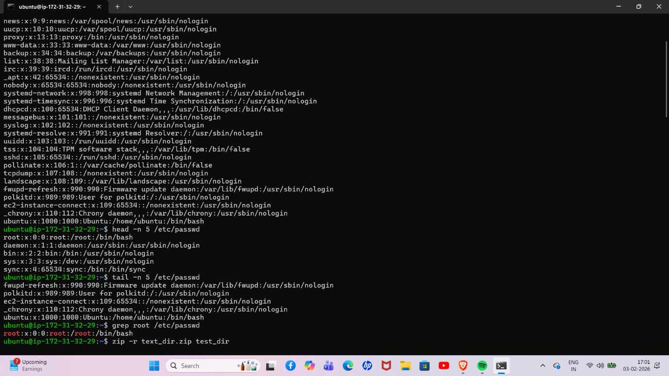

4. Zipping and Unzipping
Compress the test_dir directory into a file named test_dir.zip using zip.
Unzip test_dir.zip into a new directory named unzipped_dir.

Ans : zip -r text_dir.zip text_dir
Unzip text_dir.zip -d unzipped_dir

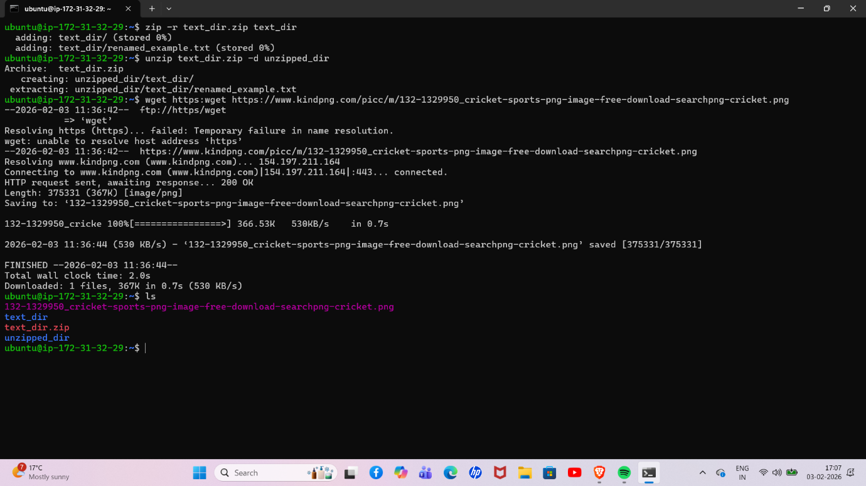

5. Downloading Files
Use wget to download a file from a URL (e.g., https://example.com/sample.txt).

6. Changing Permissions
Create a file named secure.txt and change its permissions to read-only for everyone using chmod.

7. Working with Environment Variables
Use export to set a new environment variable called MY_VAR with the value "Hello, Linux!".

And 6 : chmod 444 secure .txt
Ans 7 : export MY_VAR=”HELLO, LINUX!”

